Modulation Module

The modulation module in the channel simulator allows the user to select from three modulations: binary phase shift keying (BPSK), quadrature phase shift keying (QPSK) and two frequency minimum shift keying (2-MSK). These three modulations exhibit different spectral and bit error rate (BER) characteristics. The module allows the user to set the symbol period (T_{s}), the number of samples per period (S_{s}) and the carrier center frequency (f_{c}). Because of the large number matrix operations carried out throughout the simulator, S_{s} is calculated in the channelsim class and passed to all submodules. Otherwise, each submodule would need to reshape incoming matrices before executing multiplications, additions, and some other operations. The amplitude of all modulations is set at , since the user can arbitrarily set the SNR of the channel by adjusting parameters in the multiplicative (fading) and additive (AWGN) noise modules.

Binary Phase Shift Keying (BPSK)

The simulator's BPSK is based on the modulation described in Wireless Communications, page 295-298. The formula for the BPSK waveform is given by:

The modulation object accepts a string variable representing the binary information to be modulated. For example, an acceptable input to the bpskMod.run(binaryString, [plot]) method is “10010011”, or any other combination of ASCII '1' and '0' of any length. Using any other ASCII character will result in an exception in the bpskMod.bpskMod method, specifically a failure to find the character in the lookupdict variable. The bpskMod.run method calculates the length of the string, and calls the bpskMod.bpskMod method N_{periods} times to generate waveform arrays based on the number of samples per period, the symbol period and the carrier frequency. Each array returned by the bpskMod.bpskMod method will have length S_{s}. The bpskMod.run method uses the Numpy command “hstack” to combine the arrays returned by bpskMod.bpskMod. The resulting array is of length S_{s} x N_{periods}. If the run command is called with the argument plot = True, the method will us Pylab to plot N_{periods} of the returned waveform. An example of the BPSK wavefrom is shown below.

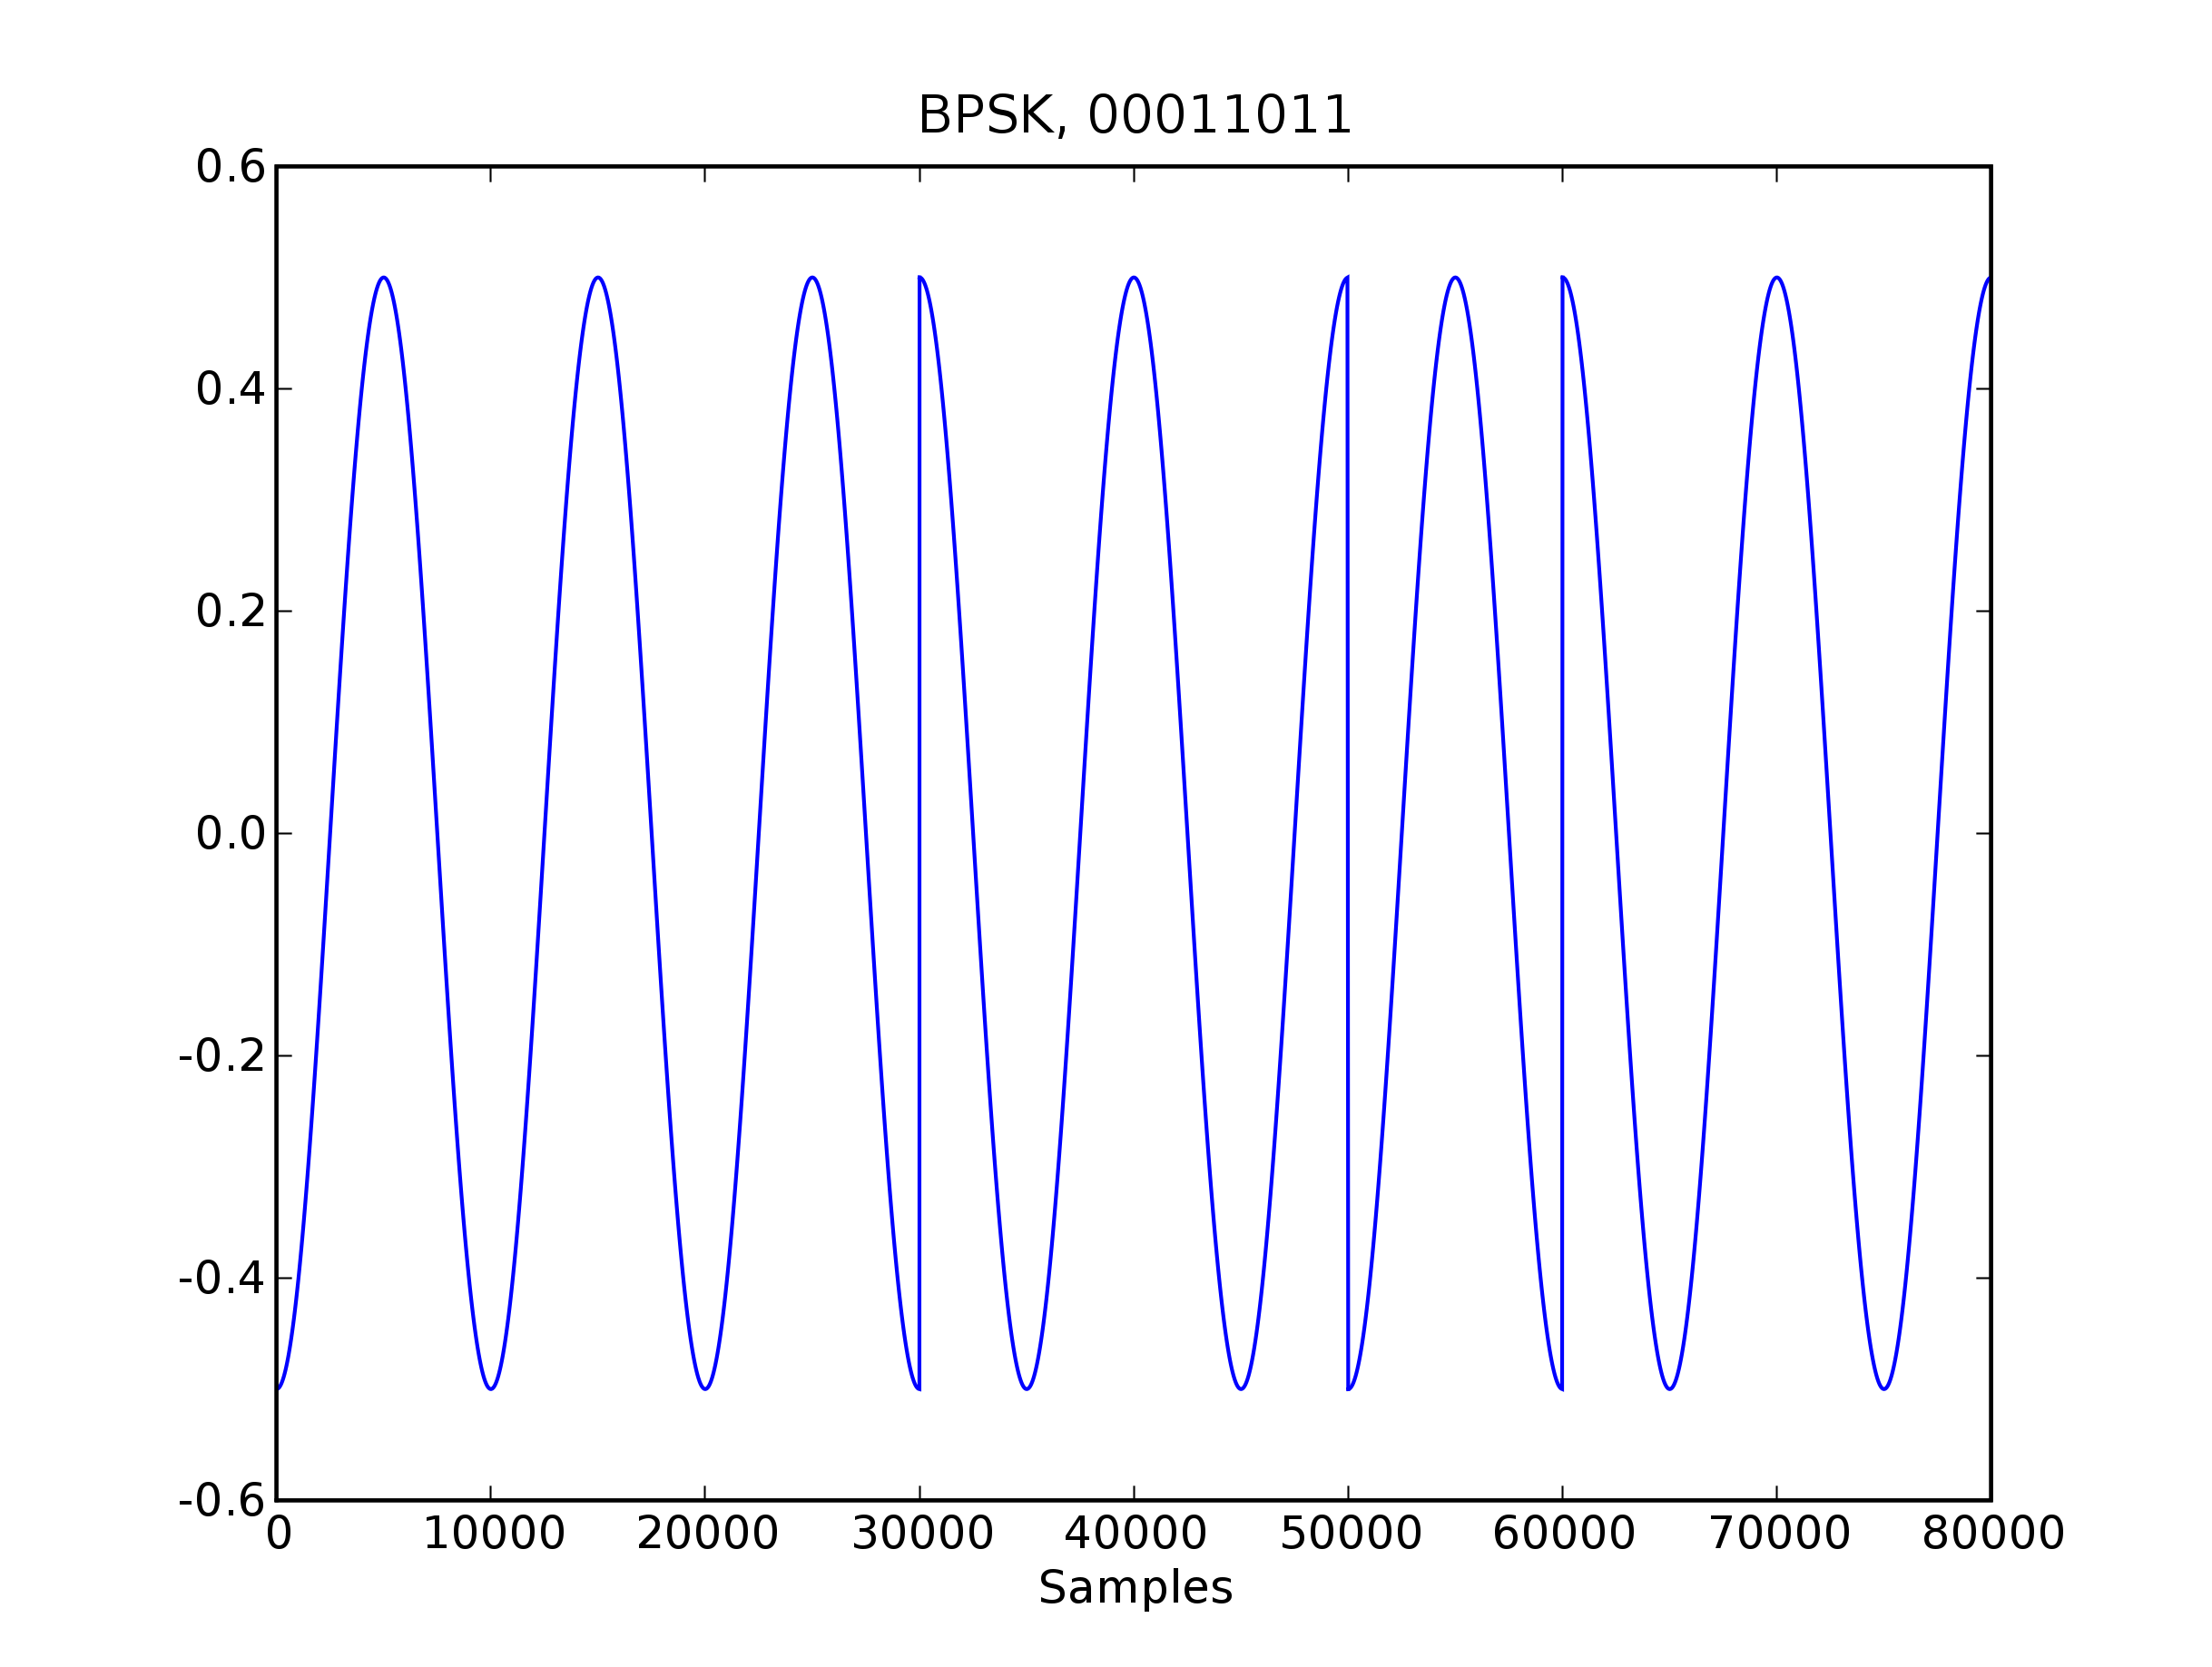Fig. 1: Example of BSPK modulation generated by bpskMod.run method. In this case the carrier frequency is 10kHz and the symbol period is 1ms.

Quadrature Phase Shift Keying (QPSK)

The QPSK modulator is based on the modulation described in Wireless Communications, page 300 – 303. The formula for the BPSK waveform is given by:

In this implementation:

Symbol | Phase Offset
“00” | 0
“01” | π/2
“10” | π
“11” | 3π/2

The class operates similarly with the BPSK modulation class, with the exception that binary values are passes in two bit chunks to the qpskMod.qpskMod method. Passing a binary string to the qpskMod.run method with length not divisible by two does not result in an exception, but the method will only return arrays representing the first N_{periods} -1. An example of the QPSK modulation is show in the figure below.

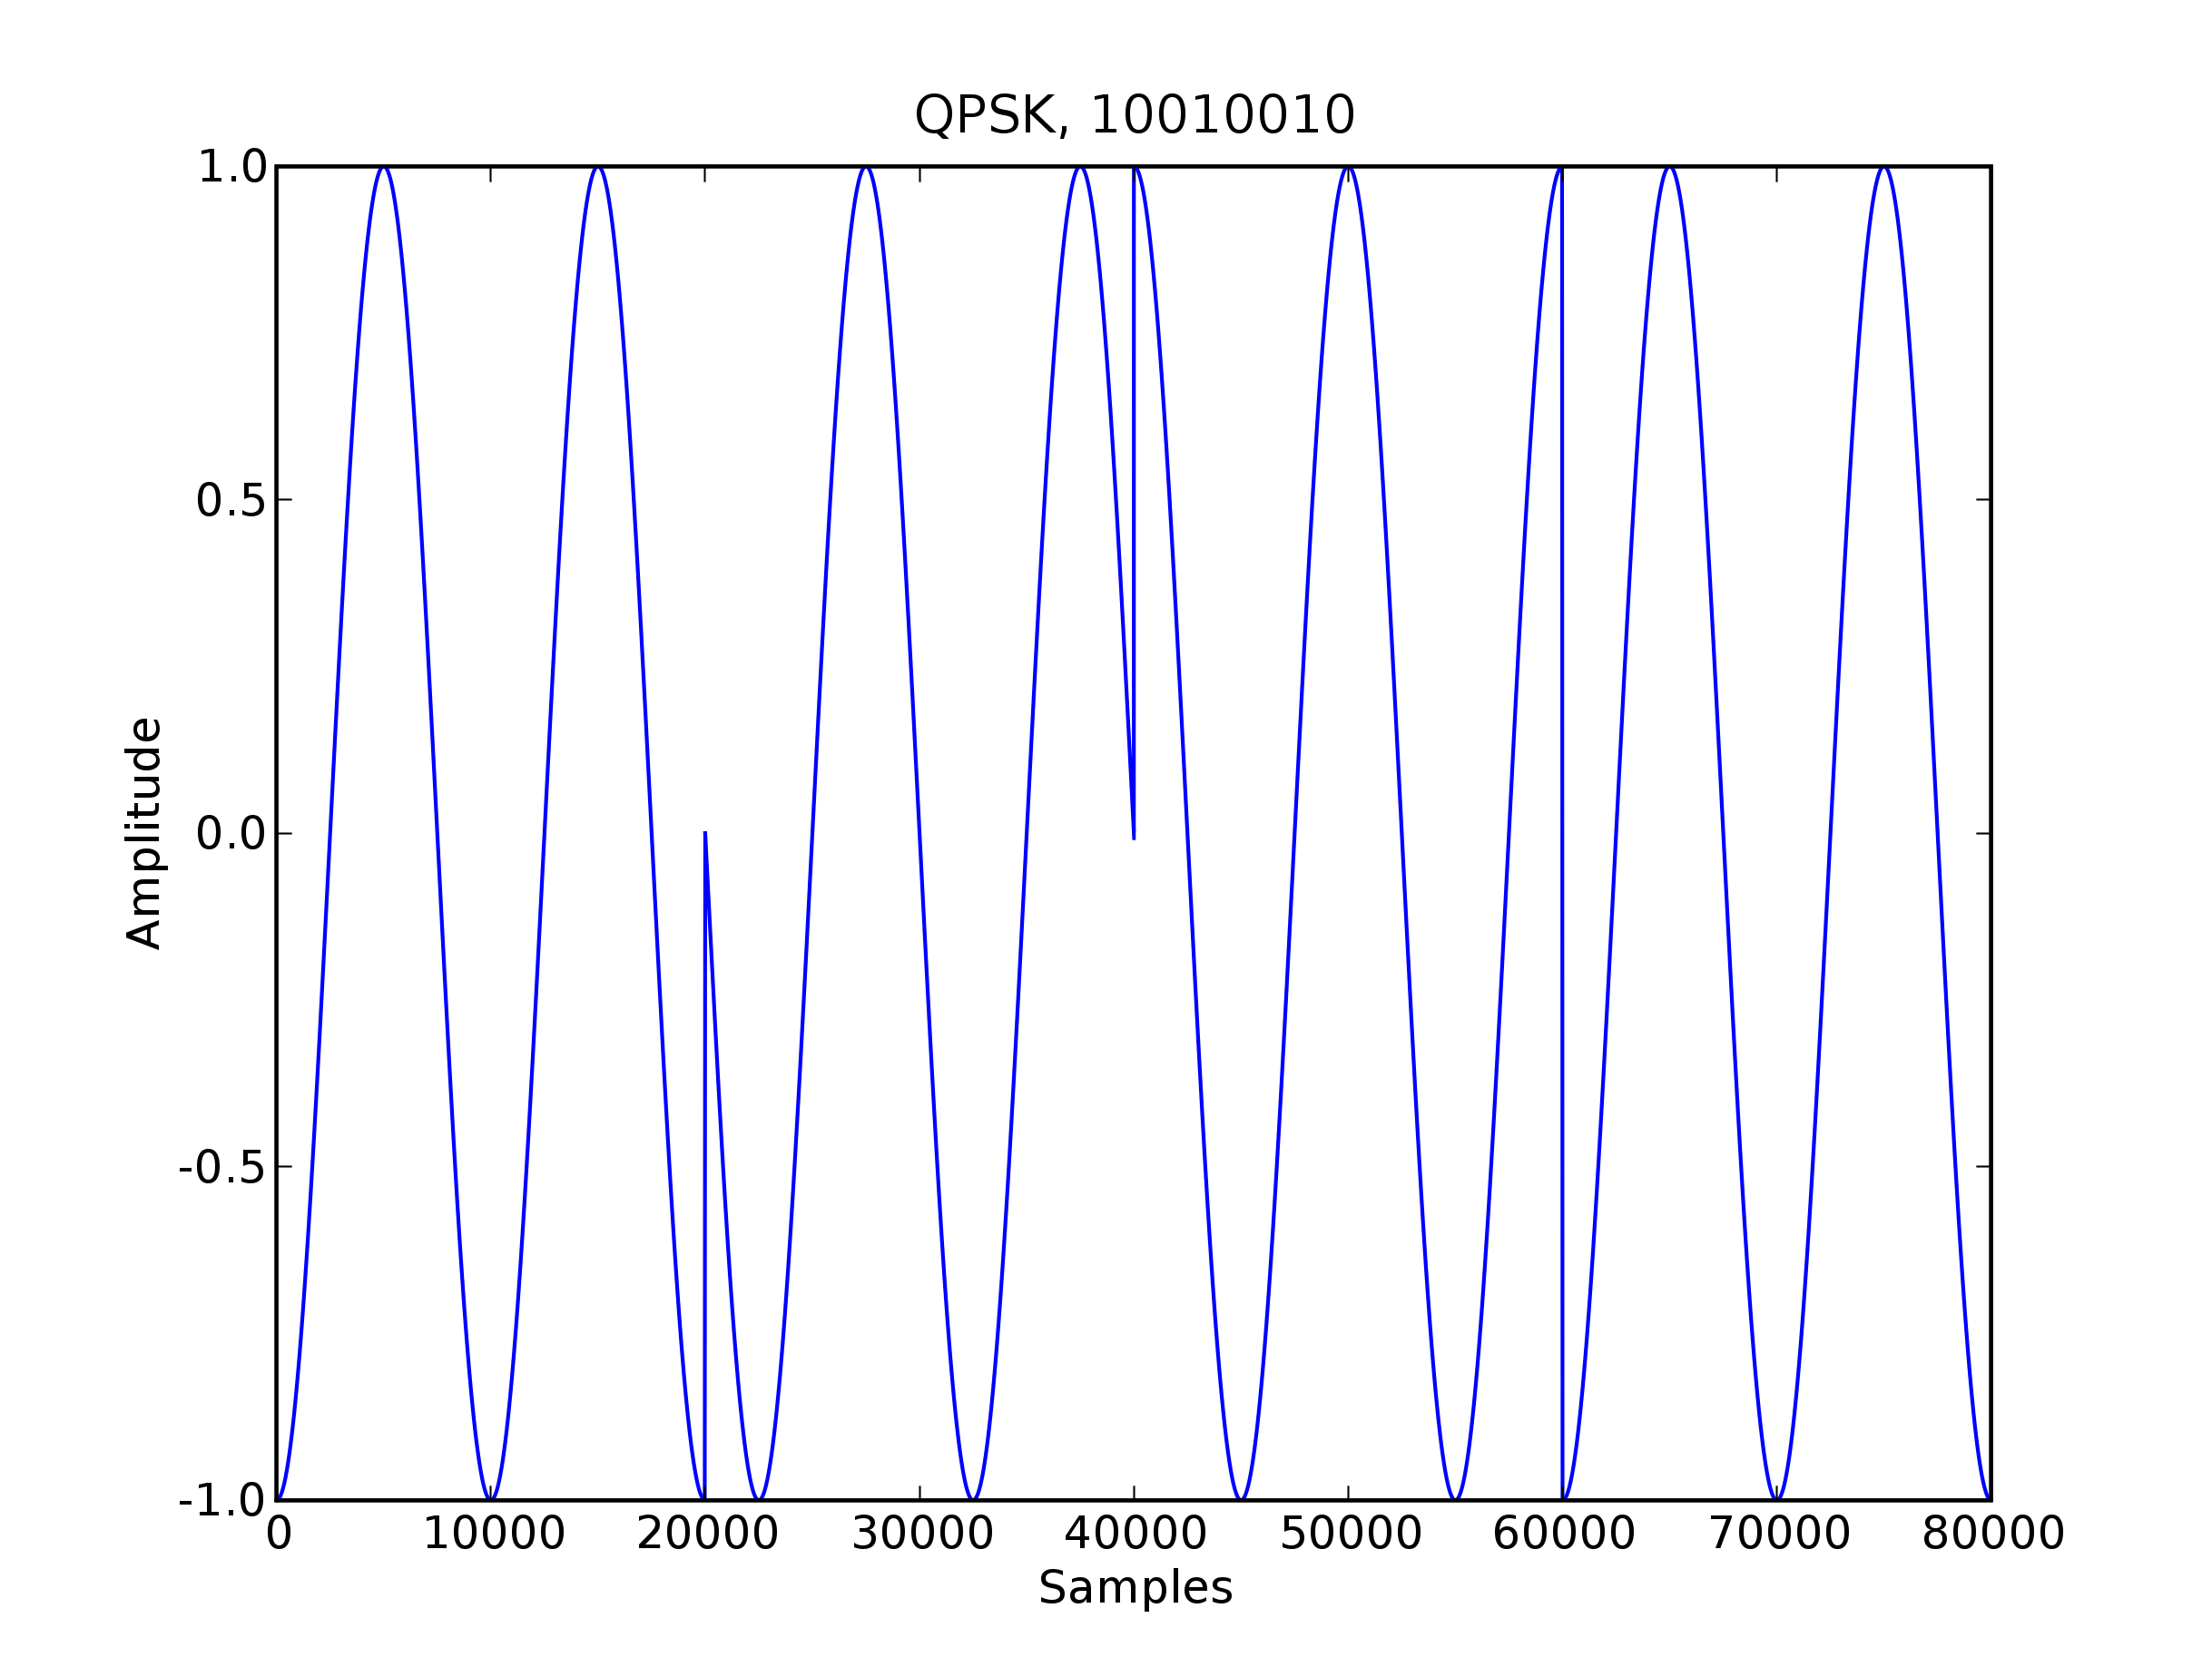Fig. 2: QPSK modulation generated by qpskMod.qpskMod method. In this case the carrier frequency is 10kHz and the symbol period is 1ms.

Two Frequency Minimum Shift Keying (2-MSK)

The 2-MSK modulator is based on the modulation described in Digital Communications, page 192 – 195. The formula for the 2-MSK waveform is given by:

Unlike the two memoryless modulations BPSK and QPSK, MSK requires that the modulator track two pieces of information: the value of the last bit, and the current phase of the signal. When the mskMod.run method calls the mskMod.mskMod method, the array is generated by adjusting the phase of the resulting signal with these two pieces of information. The array is delayed by the mskMod.phase attribute, and then, depending on whether there has been a change in the bit from the previous bit, delayed π/2 if there has been a change.
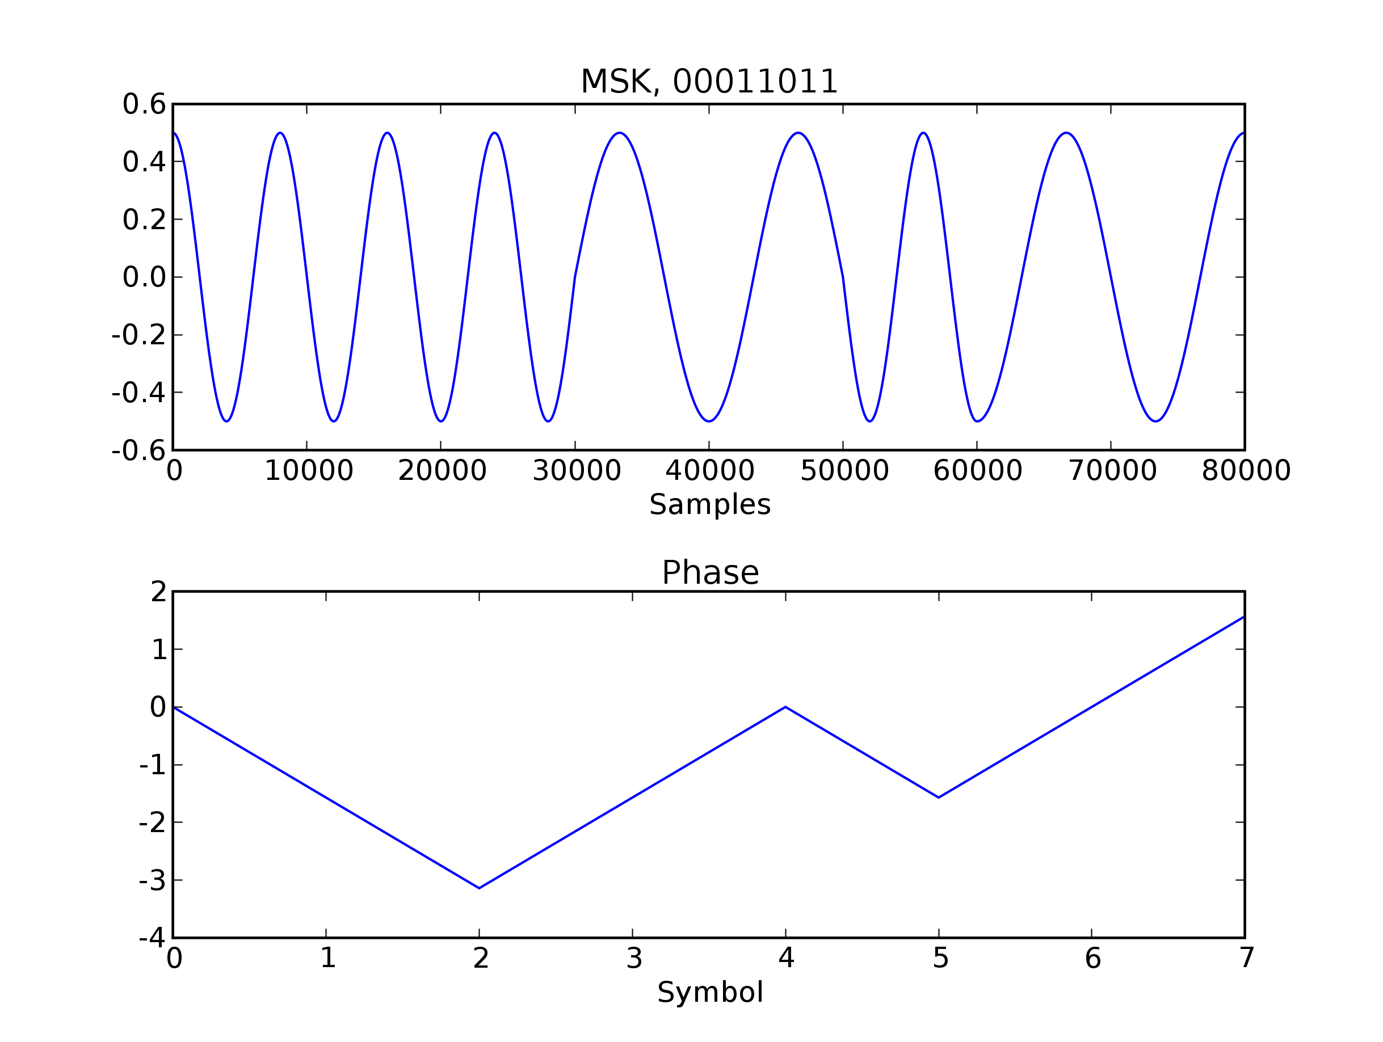Fig. 3: 2-MSK modulation generated by mskMod.run method. In this case the center frequency is 10kHz and the symbol period is 1ms. The lower subplot shows the signal phase changes.
Spectral Performance

The FFT function in the Numpy.fft module allows the user to transform the time-domain signal into a frequency domain representation. Taking the FFT of the three modulations in the wireless channel simulator yields the figure below. The three modulations perform as described in Digital Communications, by Proakis and Wireless Communications by Rappaport. The carrier frequency is set at 50kHz and the modulations are all invoked using the same binary sequence. The 2-MSK main lobe is slightly wider than the QPSK modulation, but the side lobes drop up much more quickly with frequency. The results shown in the figure match well with Figure 4.4-5 in Proakis.

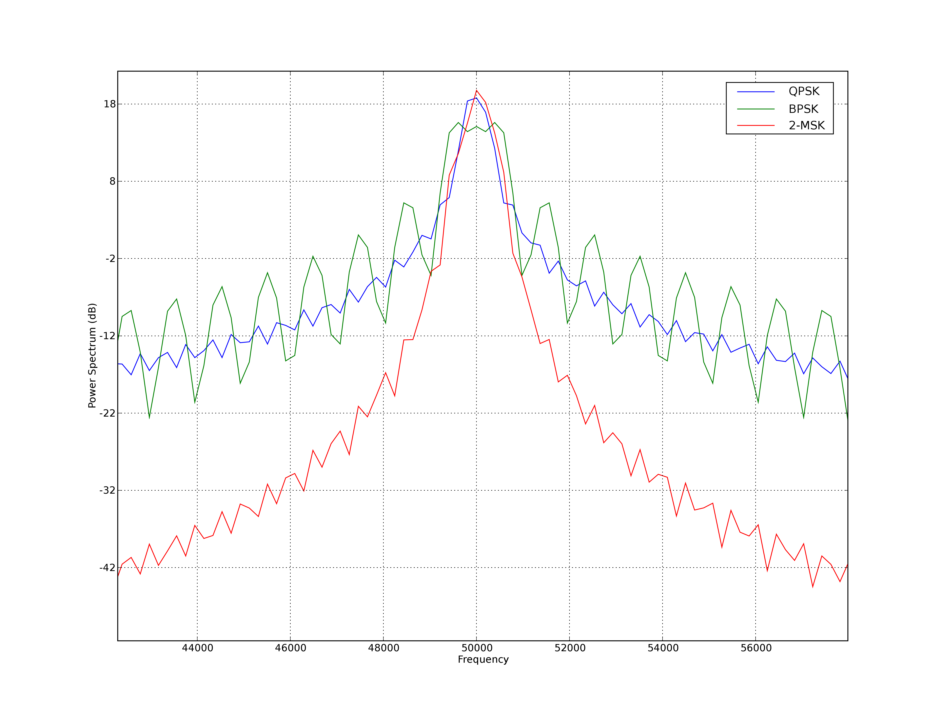Fig. 4: Spectra of QPSK, BPSK, & 2-MSK generated by the modulation.py module.
Usage:

from modulation import *
mminstance = mskMod(samples, symperiod, frequency)
outputarray = mminstance.run(binaryString)

samples: The number of samples of the waveform in one symbol period
symperiod: The duration of one symbol period
frequency: The modulation carrier frequency
binaryString: A binary string input, i.e. '00011011'
outputarray: An outgoing signal array

